3.3 Viewing Logs in Multicontainer Pod

In this demo, we will show you how to view logs in multicontainer pod.

* Login to your aws console
* Restart your ec2 instance and your EKS cluster nodes
* Open your terminal and SSH to the ec2 instance

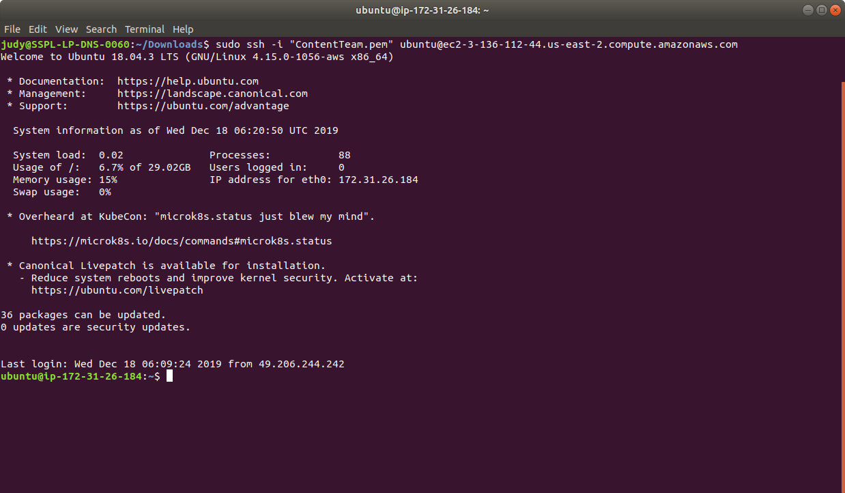

* If you don’t have an existing EKS cluster, create one with the command, **eksctl create cluster --name=myeks-cluster --nodes=2 --region=us-east-2**
* Check your running pods by **kubectl get pods** command as shown below:

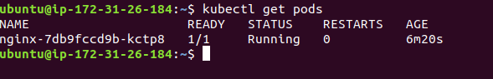

* To view logs of a pod running in a single container, use the following command **kubectl logs <podname>.**
* View all the logs of a pod running a single container inside it. This will also show the appending logs at run time. This can be achieved via running command:

**kubectl logs -f podname**

